**Module 2 Assignment 2: JavaScript Advance Concepts**

**Haoze Zhang**

**Ira A. Fulton Schools of Engineering, Arizona State University**

**IFT 458/598: Middleware Programming & Database Security**

**Prof. Dinesh Sthapit**

**September 14, 2022**

**1:**

**Requirements:**

We are going to design an web application based on Loan Domain.

**Req 1: Create a JavaScript Objects with the following properties:**

Id

customerName

phoneNumber

address

loanAmount

interest

loanTermYears

loanType

description

calculatedLoanAmount (** Assign the following business logic to calculate the loan amount. By creating a JavaScript function)

To calculate the loan amount, we use the loan equation formula in its original form: P V = P M T i [ 1 − 1 ( 1 + i) n]. Example: Your bank offers a loan at an annual interest rate of 6%, and you are willing to pay $250 monthly for 4 years (48 months).

Req 2: Create an array of loans and add five instances of the above JavaScript objects based on the above specifications

Req 3: List all the array elements with the grand total loan amount using console.log statements.

**Ans:**

**Github url:** <https://github.com/zhzhaoze/IFT458-Middleware-Programming-M2-Assignment2-ES6-Modern-JavaScript-JavaScript-Advance-Concepts>

**The data.json (five instances):**

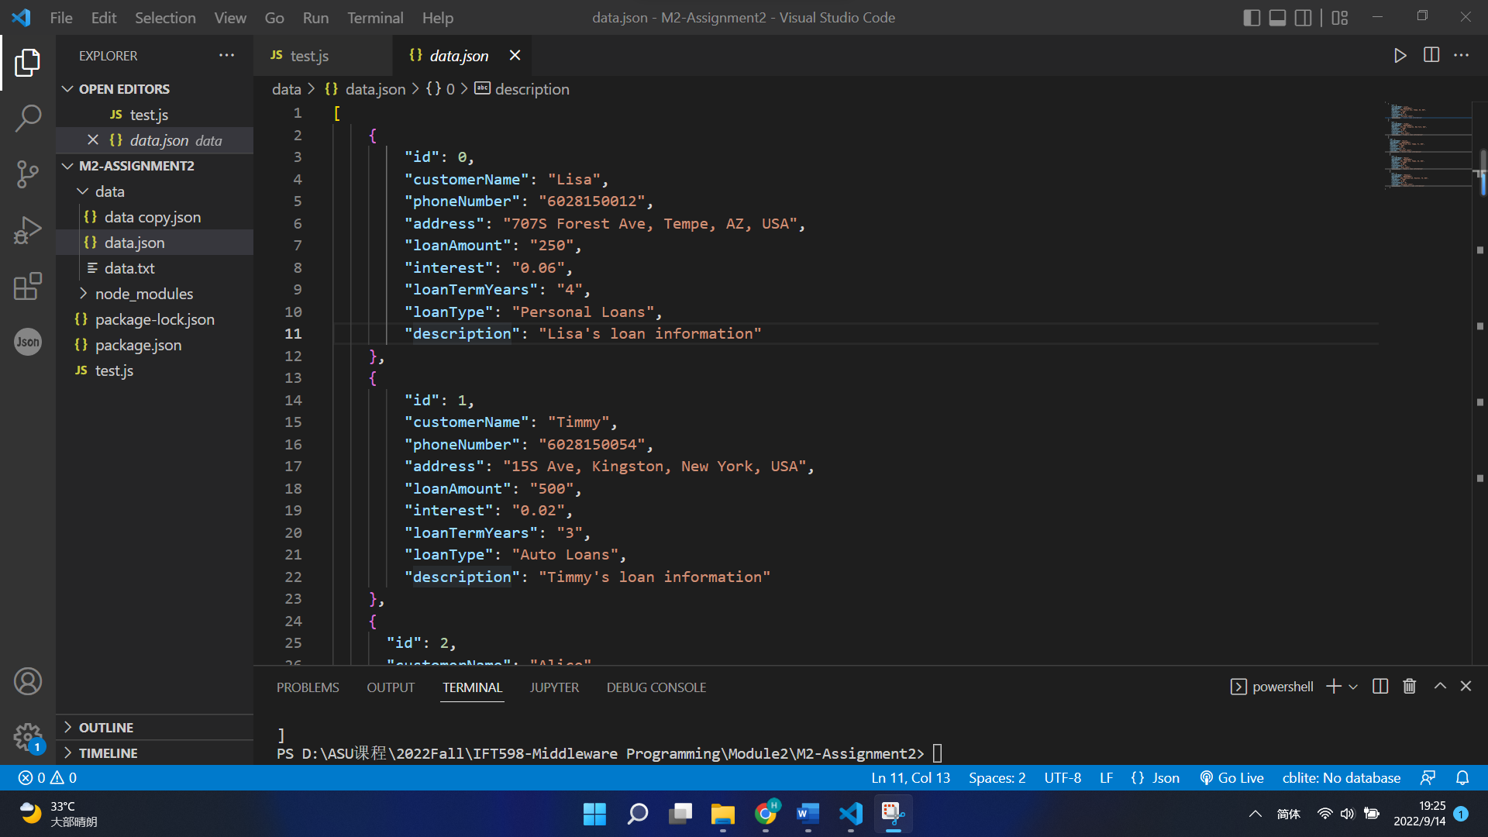

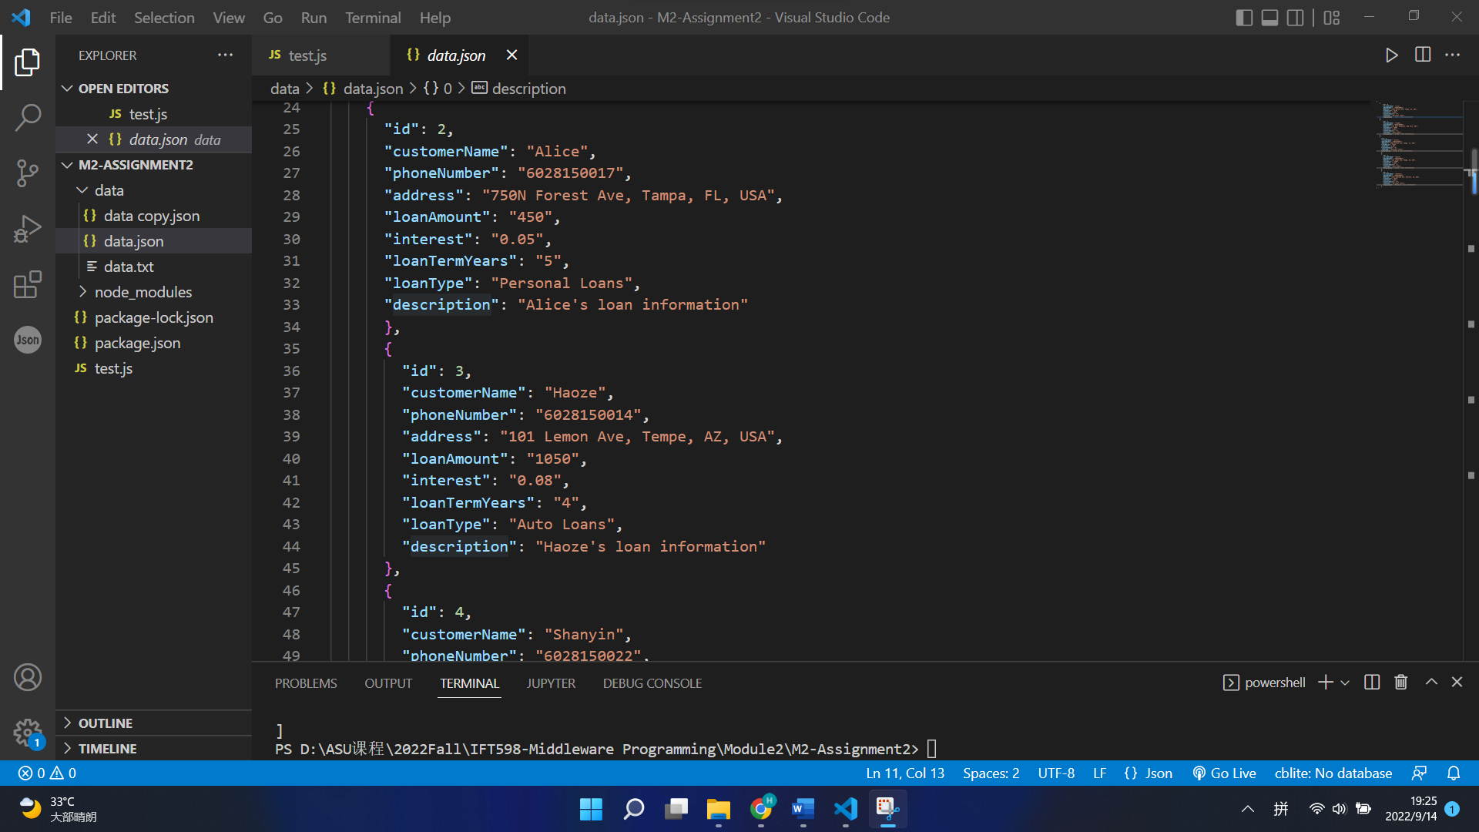

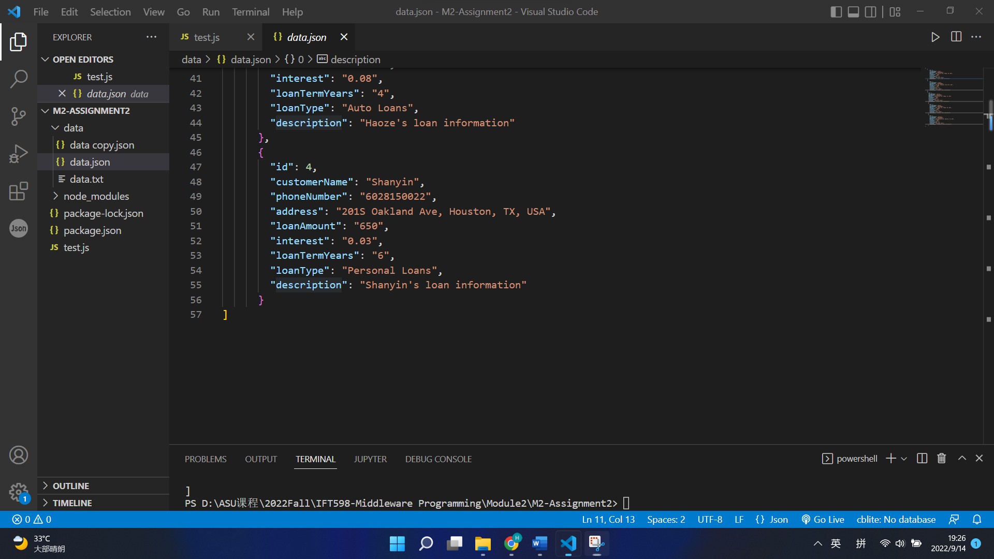

**Code of data.json:**

[

{

"id": 0,

"customerName": "Lisa",

"phoneNumber": "6028150012",

"address": "707S Forest Ave, Tempe, AZ, USA",

"loanAmount": "250",

"interest": "0.06",

"loanTermYears": "4",

"loanType": "Personal Loans",

"description": "Lisa's loan information"

},

{

"id": 1,

"customerName": "Timmy",

"phoneNumber": "6028150054",

"address": "15S Ave, Kingston, New York, USA",

"loanAmount": "500",

"interest": "0.02",

"loanTermYears": "3",

"loanType": "Auto Loans",

"description": "Timmy's loan information"

},

{

"id": 2,

"customerName": "Alice",

"phoneNumber": "6028150017",

"address": "750N Forest Ave, Tampa, FL, USA",

"loanAmount": "450",

"interest": "0.05",

"loanTermYears": "5",

"loanType": "Personal Loans",

"description": "Alice's loan information"

},

{

"id": 3,

"customerName": "Haoze",

"phoneNumber": "6028150014",

"address": "101 Lemon Ave, Tempe, AZ, USA",

"loanAmount": "1050",

"interest": "0.08",

"loanTermYears": "4",

"loanType": "Auto Loans",

"description": "Haoze's loan information"

},

{

"id": 4,

"customerName": "Shanyin",

"phoneNumber": "6028150022",

"address": "201S Oakland Ave, Houston, TX, USA",

"loanAmount": "650",

"interest": "0.03",

"loanTermYears": "6",

"loanType": "Personal Loans",

"description": "Shanyin's loan information"

}

]

**The test.js:**

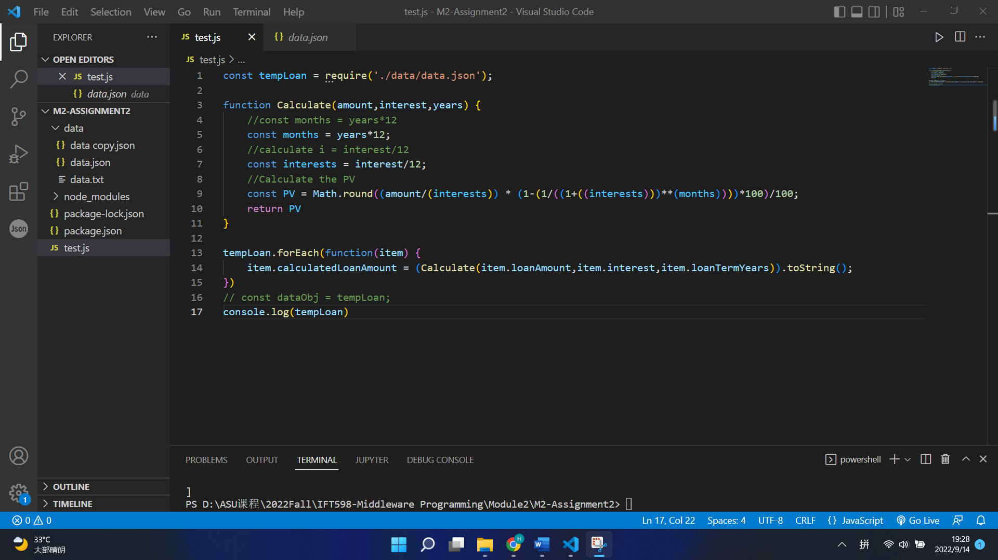

**Code of test.js:**

const tempLoan = require('./data/data.json');

function Calculate(amount,interest,years) {

//const months = years*12

const months = years*12;

//calculate i = interest/12

const interests = interest/12;

//Calculate the PV

const PV = Math.round((amount/(interests)) * (1-(1/((1+((interests)))**(months))))*100)/100;

return PV

}

tempLoan.forEach(function(item) {

item.calculatedLoanAmount = (Calculate(item.loanAmount,item.interest,item.loanTermYears)).toString();

})

// const dataObj = tempLoan;

console.log(tempLoan)

**The screenshot of result:**

